**WEBSITE HTML FEEDBACK**

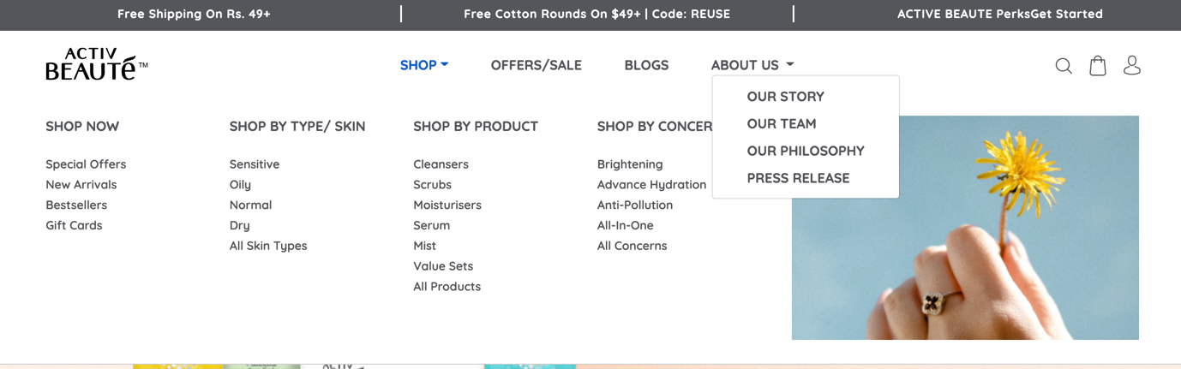

1. The Font of the drop down Menu under About Us should be Sentence Case not Caps-lock & should be similar to the size of Special Offers.

Our Story

Our Team

Press Release

1. The drop-down Menu is as below:

|  |  |  |  |
| --- | --- | --- | --- |
| **SHOP** | **SHOP BY SKIN TYPE** | **SHOP BY PRODUCT** | **SHOP BY CONCERN** |
| **Special Offers** | Sensitive | Face Wash | Anti-Pollution |
| **New Arrivals** | Oily | Scrubs | Advance Hydration |
| **Bestsellers** | Normal | Moisturisers | Acne Control |
|  | Dry | Serum | Brightening |
|  | All Skin Types | Mist | All-in-One |
|  |  | Value Sets | All Concerns |
|  |  | All Products |  |

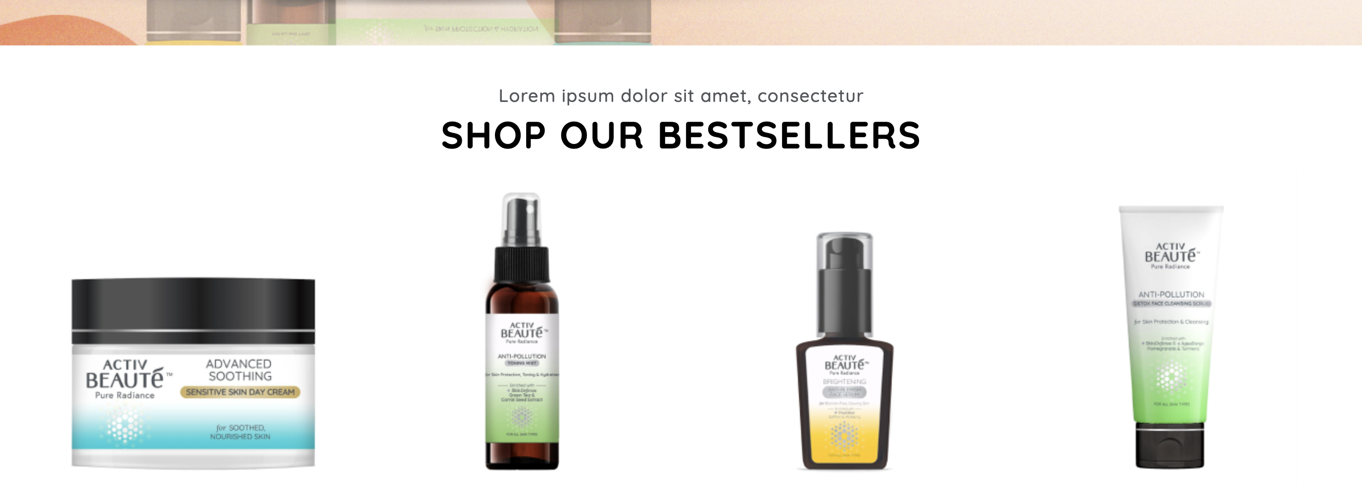

1. Text : **Lorem ipsum dolor sit amet, consectetur** has to be replaced with below text:

**Goodness of Nature & Power of Science**

We’ve harnessed the potent botanically sourced active ingredients & pure extracts from nature to bring you products that go deep beneath the skin’s surface to transform the way your skin looks, feels and behaves.

1. Little space needs to be given between the above text & the heading – SHOP OUR BESTSELLERS
2. Align the space for heading text of ‘CUSTOMER REVIEWS’

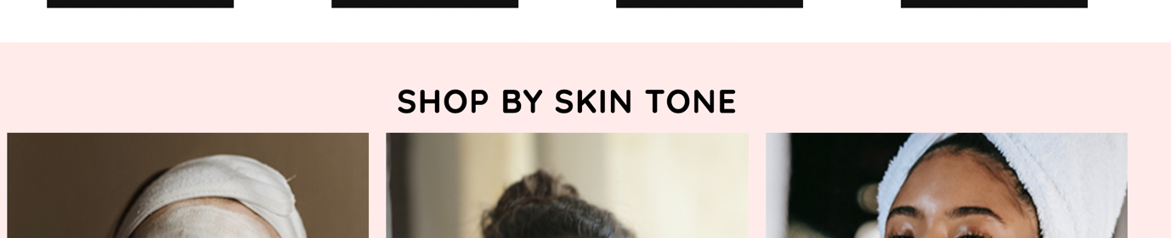

1. Change the shop Now button to black & change the size as per the ones below the product in the shop best seller section

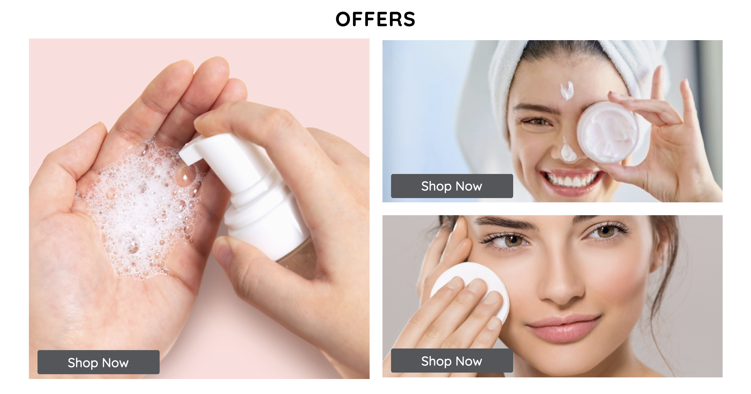

1. Sending you the open files of the artwork from where you have to take the symbols. The symbols that needs to be on the website are as follows:

* Not Tested on Animals
* Dermatologically Tested
* Clinically Proven Actives
* No Mineral Oil/No SLS/NO Paraben



1. Replace the Cleansers with Face Wash. Remove the heading Blogs.

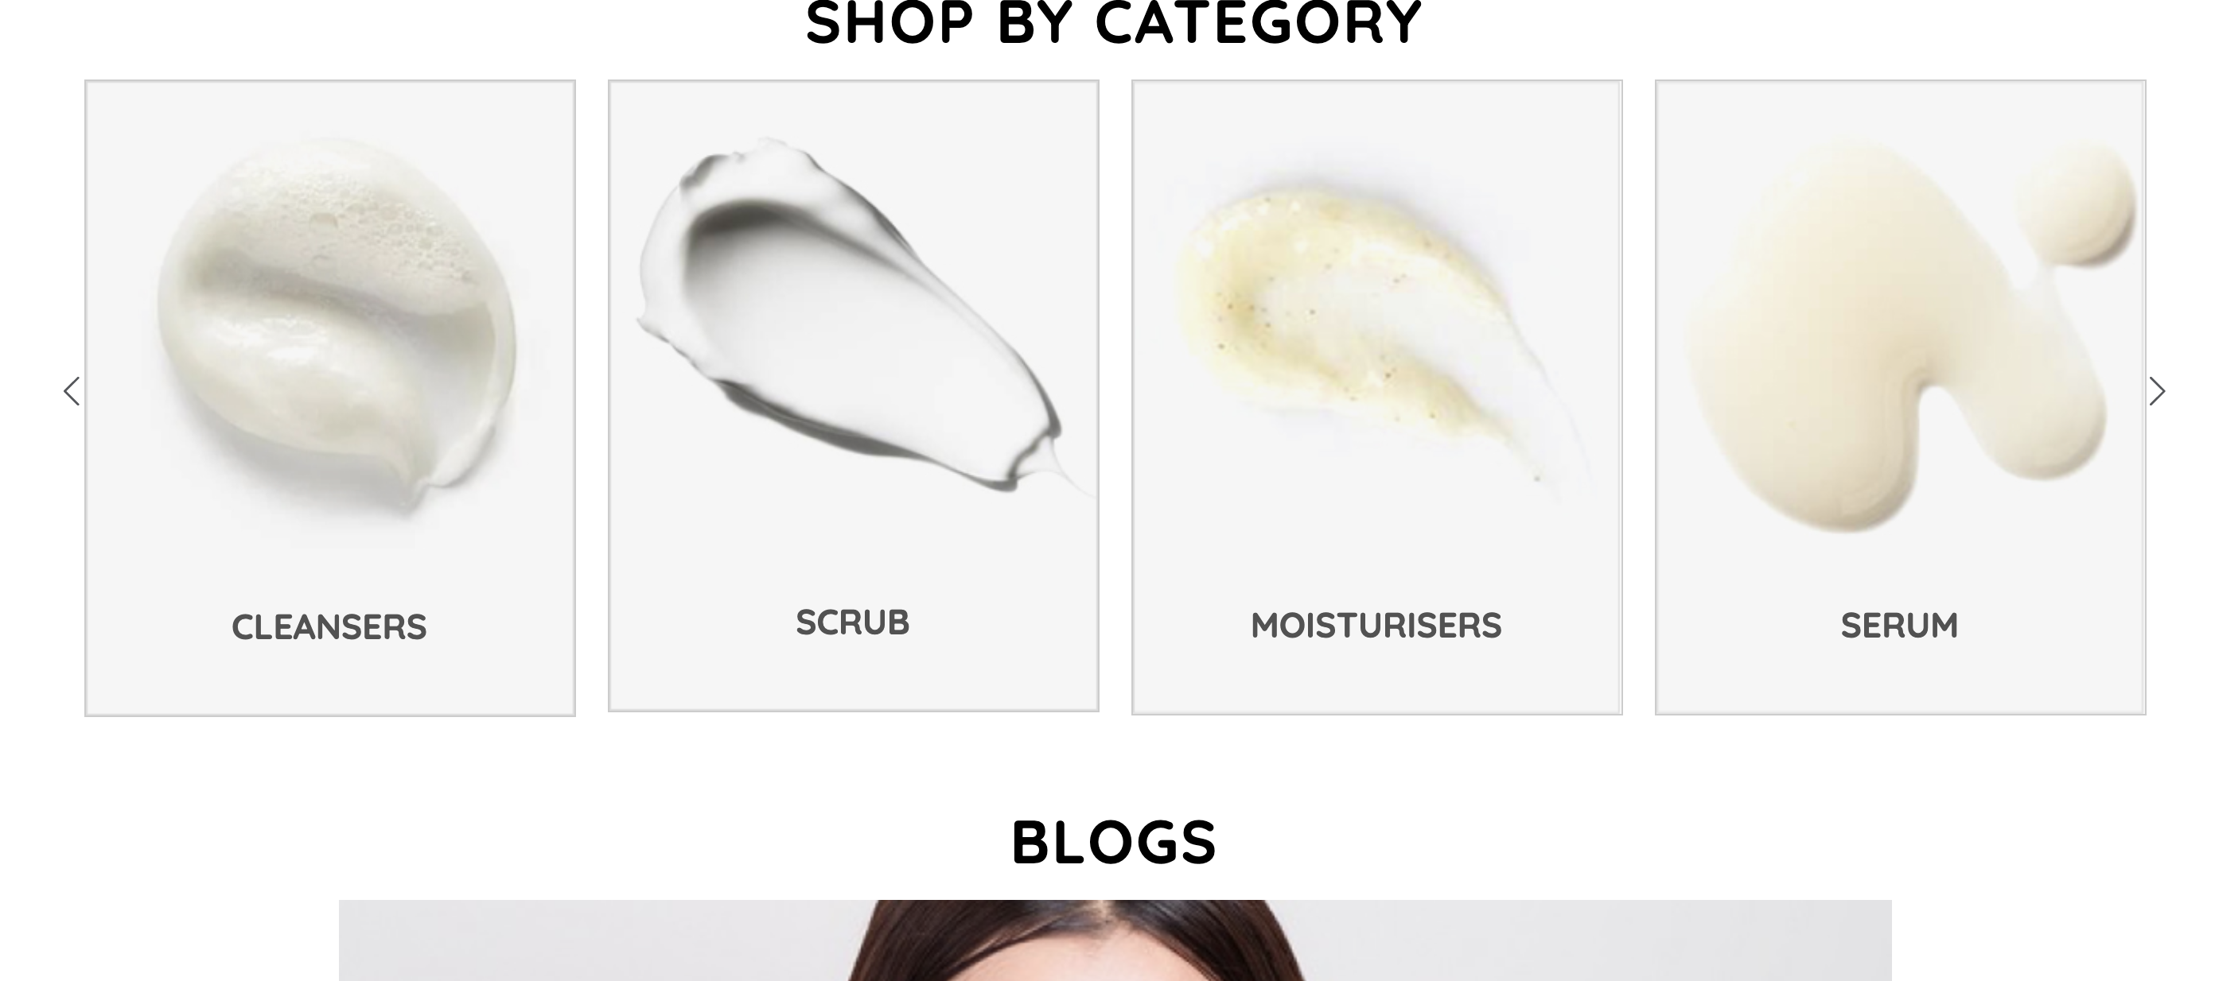

1. Space needs to be aligned for Let’s Get Social . Also, For desktop we want one social media in one line wherein for mobile view it should be 6 images.

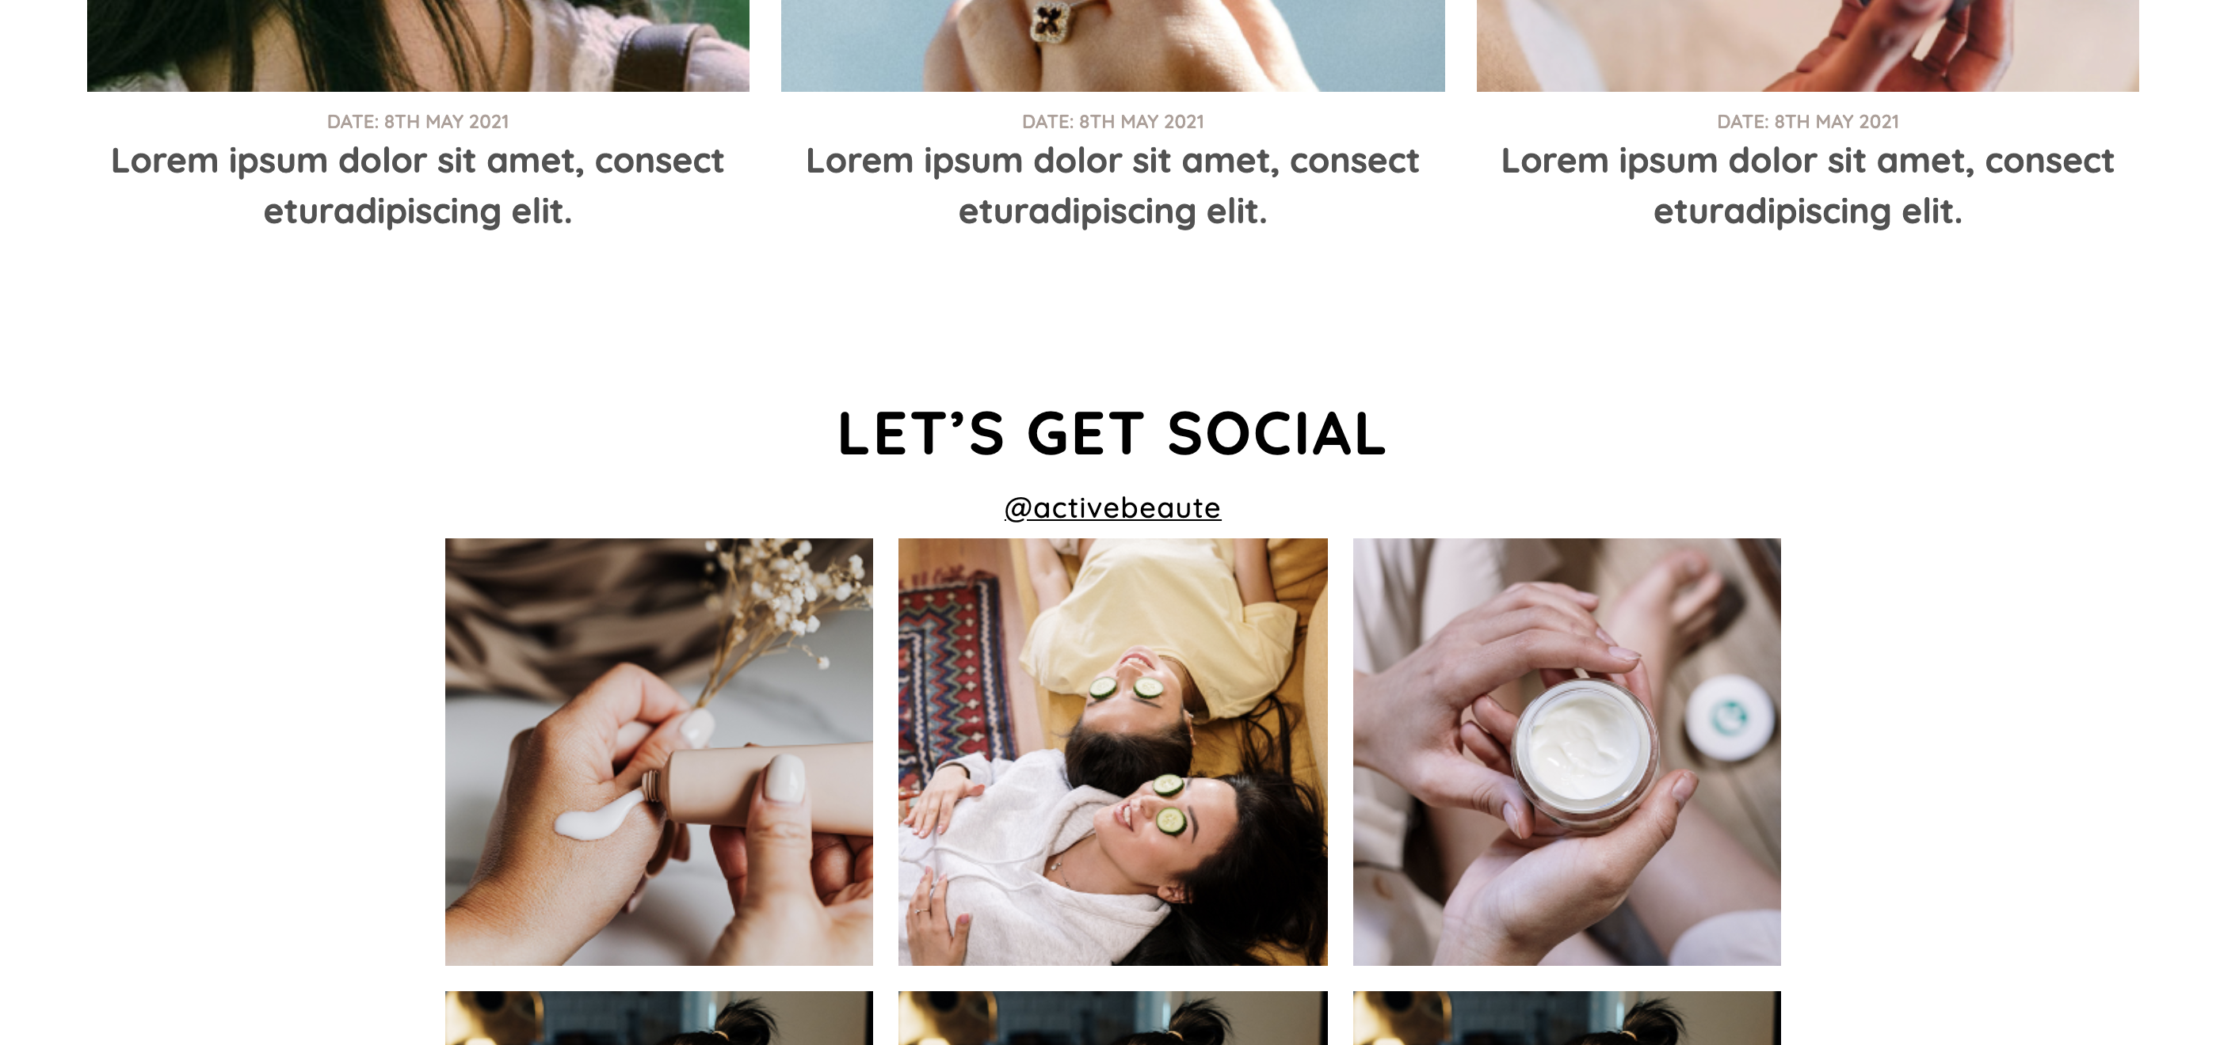

**FOR MOBILE**

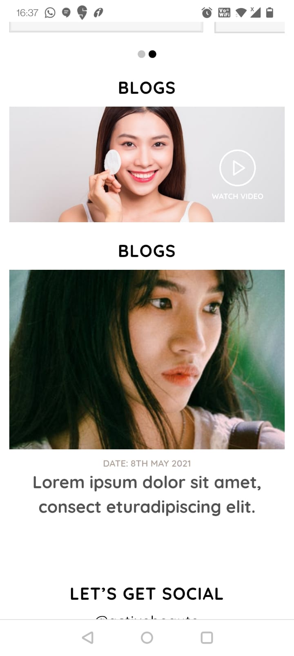

Increase the video section similar to the Blog picture size.

Remove the first BLOGS heading

Align the space between the blogs text & Let’s Get Social section.

**PRODUCT PAGE**

1. Align the space of Heading – DESCRIPTION from above.

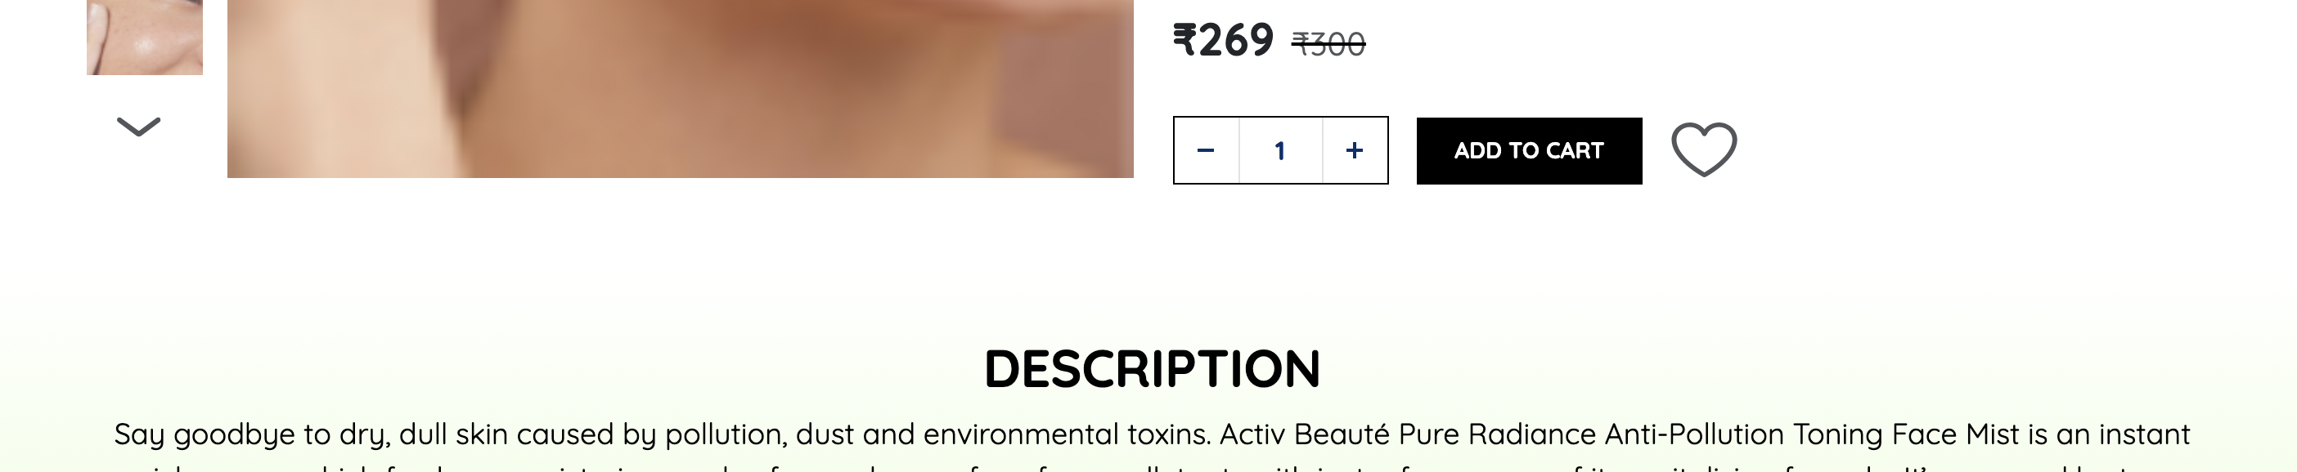

1. Align the space above the heading – KEY INGREDIENTS THAT MAKE THE DIFFERENCE. The name of the ingredients should be in Black. Text also should be in black

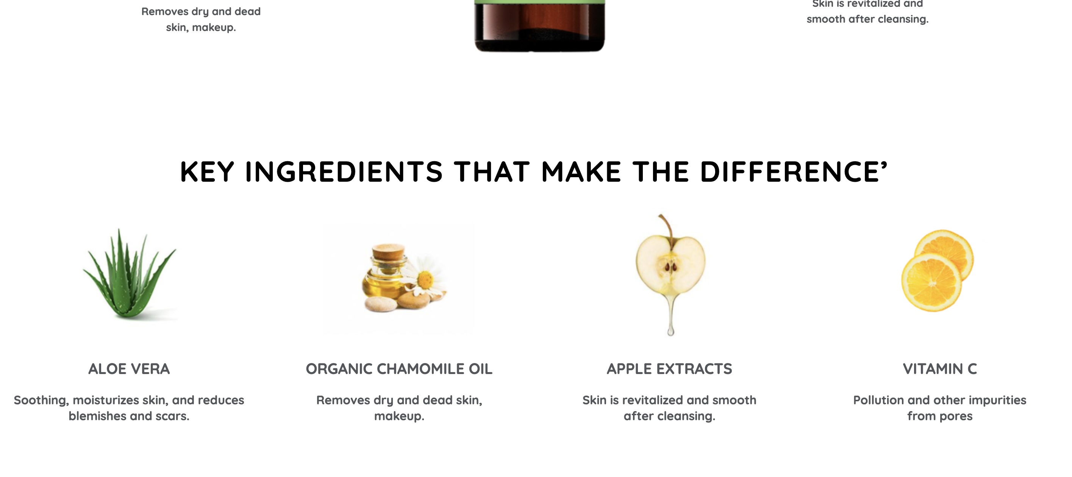

1. The Text should be in black color.

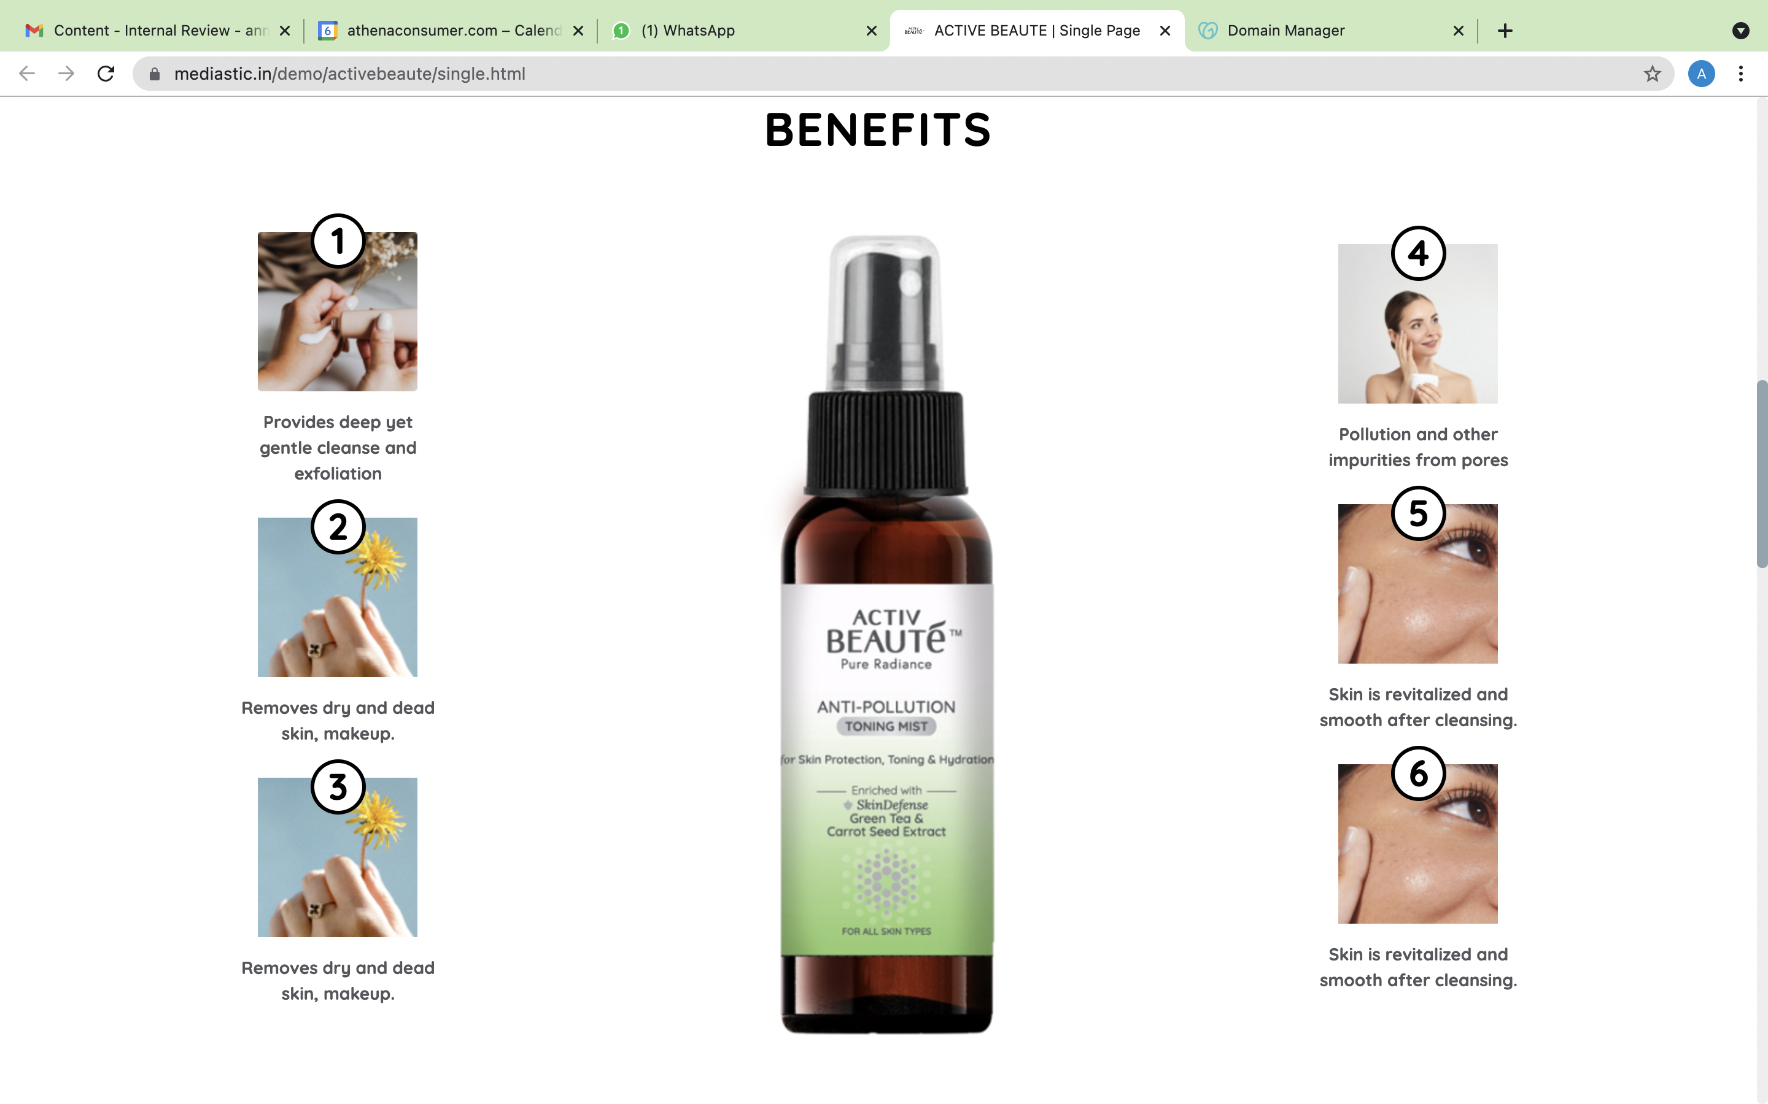

1. Centre Align the whole Directions to Use section with Image & text.

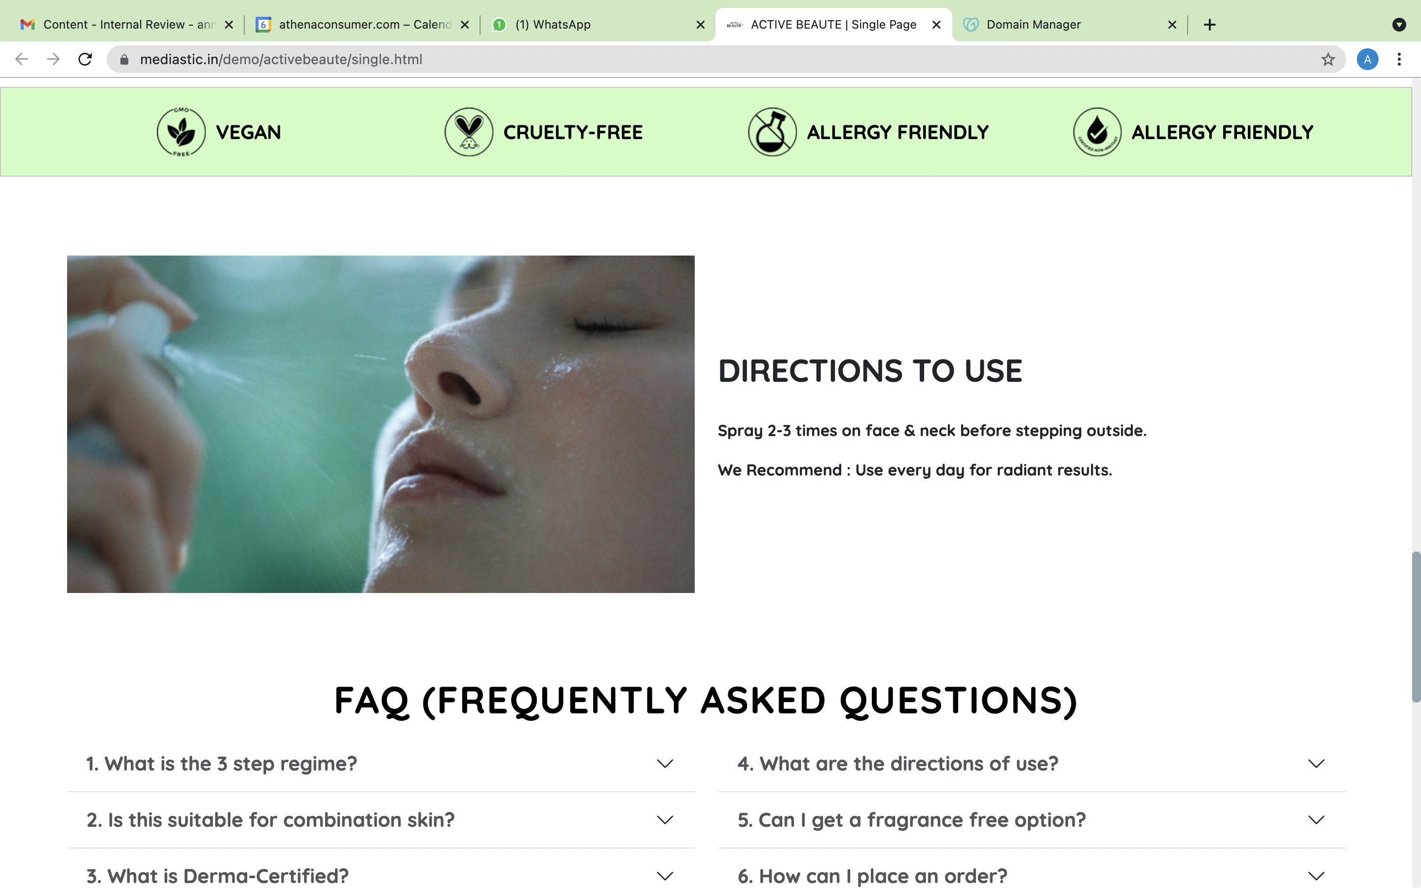

**FOR MOBILE**

1. Alignment of the text under the images

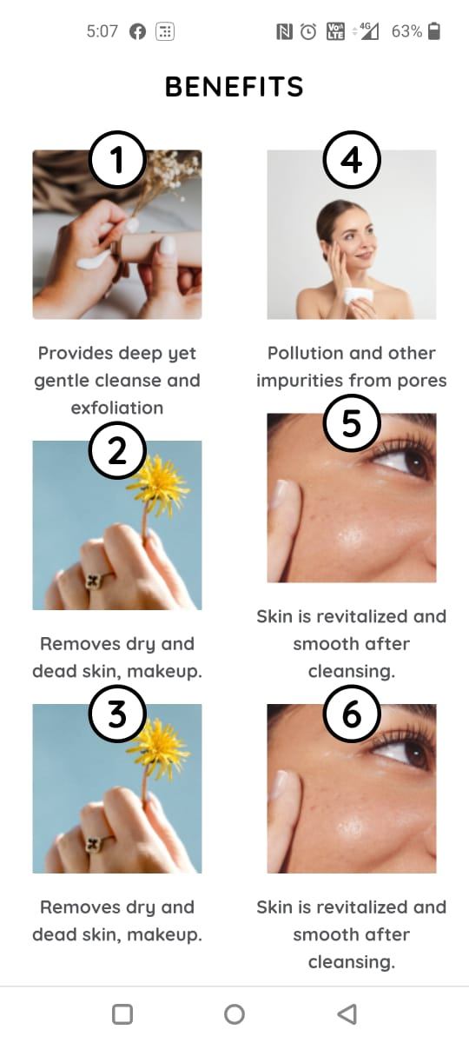

1. Align the whole text section of Directions to use.

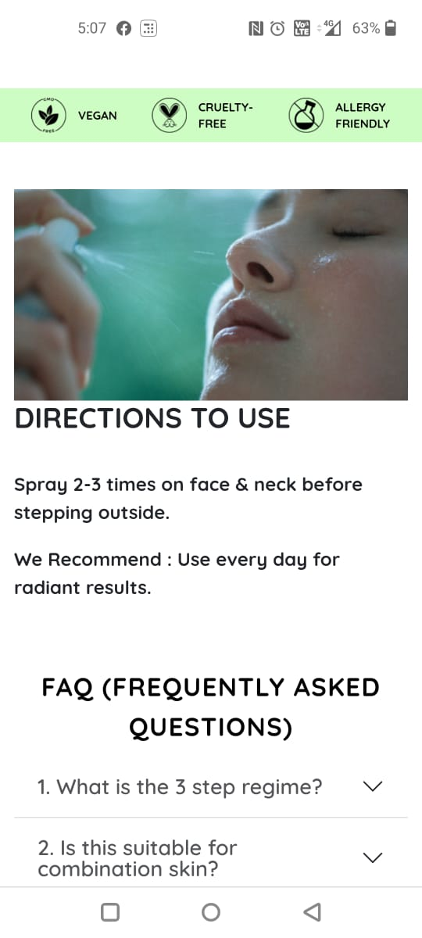

**COLLECTION PAGE**

1. Change the drop down of filters as below:

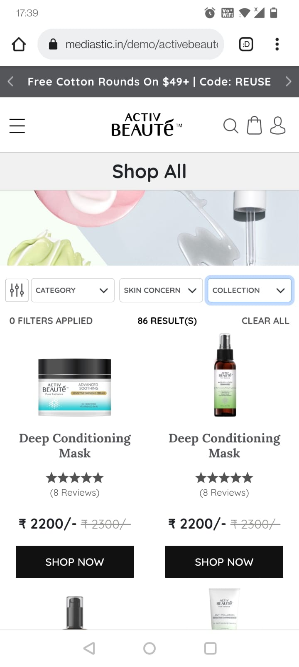

1. SKIN TYPE
2. SKIN CONCERN
3. SKIN PRODUCT

All the filters will have same options as the main menu drop down.